|  |  |  |  |
| --- | --- | --- | --- |
| Name | Role | Responsibility |  |
| Yuri Kashnovsky | Had just founded LearnIT, Inc. | software training consultancy  in the Russian capital | Another relative character |
| Emillio Arroyo-Lopez | the Argentinean-born director of the department’s distance education program |  |
| Mukhit Ashgirov | a student from Kazakhstan |  |
| Natalya Girienko | a student from Russia |  |
| Oksana Milov | a student from the Ukraine |  |
| Peter Kower | The partner with Russ Laughlin in a few business initiatives |  |
| John Foote | faculty member |  |
| Levin | professor of computer science |  |
| Dr. Viktor Polutin | the managing director of Motorola’s R&D center in Russia |  |
| Mikhail Pisarev | Russoft’s Technical Manager  Russoft’s Technical Director | The project leads, to discuss the speciﬁcs on GUI design, ongoing issues that needed to be resolved, and the planning | *Russoft project organization* |
| Russ Laughlin | Russoft’s CEO | Manage Russoft’s team |
| Sergey Nizamov | Russoft’s Team Lead | The project lead on the Russian side |
| Dennis Bramer | Account Manager  Russoft’s U.S. managing director | Count time and collect/report working hour  Build a basic level plan |  |
| Peter Jackson | The new director of the Master of  Software Engineering Program at the University of Madison (UV Madison) | Provide requirement (massive redesign and implementation of a new student-faculty-staff Web site) for Gene Fisher  Deciding choose team build SEWeb project | *The UV Madison project team* |
| Gene Fisher | Project Manager | Manage, monitor and control SEWeb project |
| Alex Rau | Webmaster  Technical Lead | Coordinate, test, and monitor this offshoring development project under  Fisher’s supervision |
| Jane Weber | Program Administrator | Get high level requirement |
| Al Molsters | System Administrator | Get high level requirement |

This is organizational structure of Team SEWeb and their outsourcing in Reading

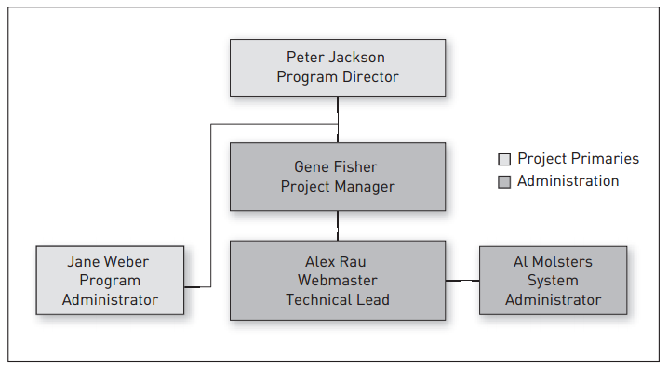

**Figure 1: UV Madison project team**

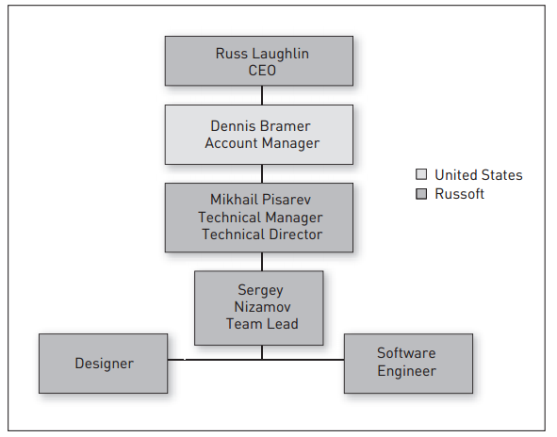

**Figure 2: Project organization**